

ASSET VERIFICATION AND RECORDING TOOL KIT


Plot 31, Bukoto Street
P.O Box 7657, Kampala, Uganda
+256 (0) 39 2000216/0772525235
email: cpa@cpa.ug

www.cpa.com

August to September 2026

VERIFICATION DETAILS

NAME OF THE REGION: | WESTERN
SUB-REGION: | TOORO
Name of Local Government | BUNDIBUGYO
VERIFIER PARTICULARS
Full name | ZALWANGO MARIA, NASSEJJE NADIA, NABBOSA SUMAYA
Contact/ email and Telephone | 0751977570/ 0754884004/ 0708098456
Supervisor/ Sub team leader
Name | DEPAUL MBONIGABA
Contact | 0788483159
Date of submission

SCHOOL VERIFICATION CHECKLIST

SCHOOL INTERVIEW/DISCUSSION GUIDE

Name of school: KABANGO SEED SS

1a | Does the Facility have a record of all assets provided under UgIFT.  (Obtain a record and verify if it has the costs and numbers supplied | Yes,
1b | If Not ask how many were supplied and when.

2 | How does this facility Maintain (repair/service/replace) the assets provided under Ugift

The facility is still under construction.

3 | Does the facility take regular record about functionality/ or breakdown of the assets provided?  Nonfunctional/ working, and reasons for non-functionality. | Yes.

4 | How has the UgIFT support helped in service delivery in the area, any issues, challenges and any recommendations for better program implementation.

- Source of employment opportunities to the community.
Issues: delay of the project
Recommendations: The programme should not be delayed for better programming, more requirements are needed because the number of students is high.

PROCEED TO VERIFICATION AFTER THIS DISCUSSION

SCHOOL FURNITURE
(School Desks, Office chairs, Laboratory stools, Book shelves)

Name of LG: NTOROKO DISTRICT Name of SCHOOL: NOMBE SEED SECONDARY SCHOOL

Equipment/ Item | Department | Asset Number | Item  Description | Life in Months | Tag Number ( engrave no.) | Date Of Pur | Date Placed In Service | Recoverable cost | Cost | Acc Dep Cost | Net Book Value | Ytd Deprn | Equipment status | Remarks
School desks | Education |  |  |  |  |  |  |  |  |  |  |  |  | They have not yet received furniture.
Office chairs
Labaratory stools
Bookshelves
Tables

ICT ITEMS TO VERIFY
(Desktop Computer, Server Processor, Network Switch 24 Port, Multipurpose Printer, UPS, Projector, Air Conditioners, Server, CCTV Camera)

Name of LG…………………………………………………………………………… Name of SCHOOL………………………….………………………………………

Equipment/ Item | Department | Asset Number | Item  Description | Life in Months | Tag Number ( engrave no.) | Date Of Pur | Date Placed In Service | Recoverable cost | Cost | Acc Dep Cost | Net Book Value | Ytd Deprn | Equipment status | Remarks
Desktop computer | Education |  | Boxed |  |  | 15/5/2025 |  |  | 4,000,000 |  |  |  | Good condition | Not in use still in store. 20 pcs
Server processor | Education |  | Boxed |  |  | 15/5/2025 |  |  | 6,000,000 |  |  |  | Good condition | Still in store, received only 1
Network switch 24 port | Education |  | Boxed |  |  | 15/5/2025 |  |  | 2,000,000 |  |  |  | Good condition | 2 are still in the store
Multi purpose printer | Education |  | Boxed |  |  | 15/5/2025 |  |  | 5,000,000 |  |  |  | Good condition | 1 still in store
UPS | Education |  | Boxed |  |  | 15/5/2025 |  |  | 350,000 |  |  |  | Good condition | 20 are still in store
Projector | Education |  | Boxed |  |  | 15/5/2024 |  |  | 5,000,000 |  |  |  | Good condition | Received 1 Still in store
Air conditioner | Education |  | Boxed |  |  | 15/05/2025 |  |  | 10,000,000 |  |  |  | Good condition | Received 1 still in store
Server | Education |  | Boxed |  |  | 15/05/2025 |  |  | 8,000,000 |  |  |  | Good condition | Received 1 still
ICT Camera | Education |  | Boxed |  |  | 15/5/2025 |  |  | 4,000,000 |  |  |  | Good condition | Received 1 still in store
LAN | Education |  | Boxed |  |  | 15/5/2025 |  |  | 12,000,000 |  |  |  | Good condition | Received 1 still in store
Power surge projector | Education |  | Boxed |  |  | 15/5/2025 |  |  | 280,000 |  |  |  | Good condition | Received 1 still in store
Firewell | Education |  | Boxed |  |  | 15/5/2025 |  |  | 2,000,000 |  |  |  | Good condition | Received 1 still in store
Wireless router | Education |  | Boxed |  |  | 15/5/2025 |  |  | 2,000,000 |  |  |  | Good condition | Received 1 in store
Router | Education |  | Boxed |  |  | 15/5/2025 |  |  | 2,000,000 |  |  |  | Good condition | Received 2 still in good condition

BUILDINGS TO VERIFY
(Non- Residential and Residential, Kitchen, Toilets/Pit latrine Water tanks, Fences etc.)

Name of LG…………………………………………………………………………… Name of SCHOOL………………………….………………………………………

Equipment/ Item | Department | Asset Number | Item  Description | Life in Months | Tag Number ( engrave no.) | Date Of Pur | Date Placed In Service | Recoverable cost | Cost | Acc Dep Cost | Net Book Value | Ytd Deprn | Equipment status | Remarks
Non residential | Education |  | Under construction |  |  |  |  |  |  |  |  |  | Good condition | Not yet used, they are 6
Residential | Education |  | Under construction |  |  |  |  |  |  |  |  |  | Good condition | They are two not yet used
Kitchen | Education |  | Under construction |  |  |  |  |  |  |  |  |  | Good condition | They are 2 not yet used
Toilets | Education |  |  |  |  |  |  |  |  |  |  |  |  | They don’t have
Pit latrine | Education |  | Under construction |  |  |  |  |  |  |  |  |  | Good condition | Not yet used.
Water tanks | Education |  | Under construction |  |  |  |  |  |  |  |  |  | One is faulty and two are working. | Not yet used they are two.
Fence |  |  |  |  |  |  |  |  |  |  |  |  |  | They don’t have
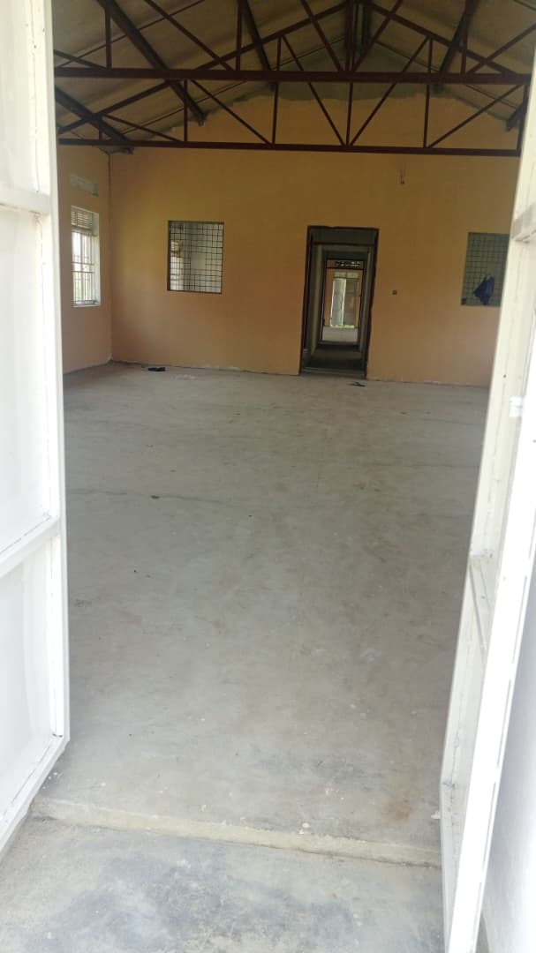
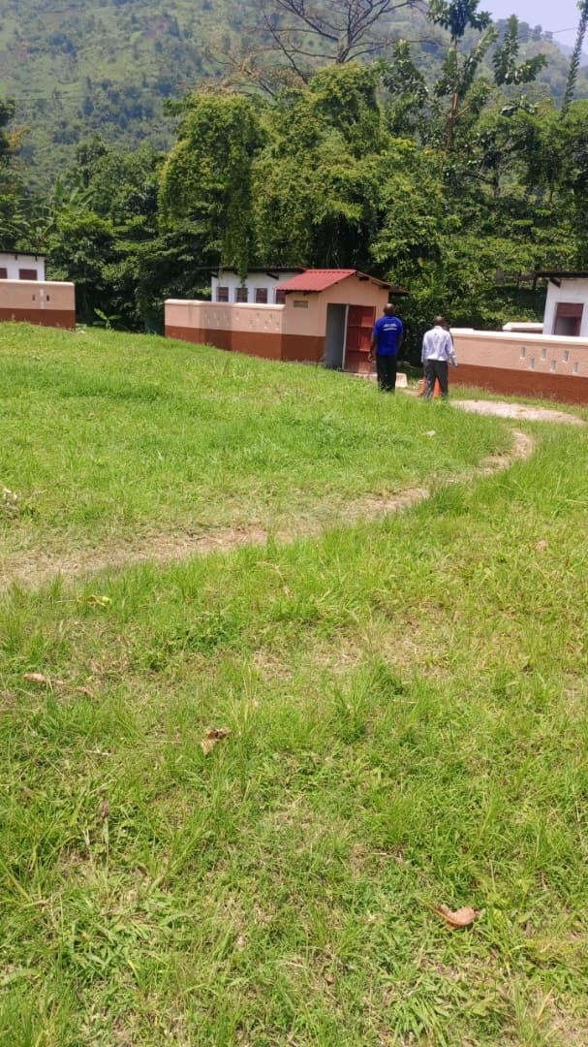
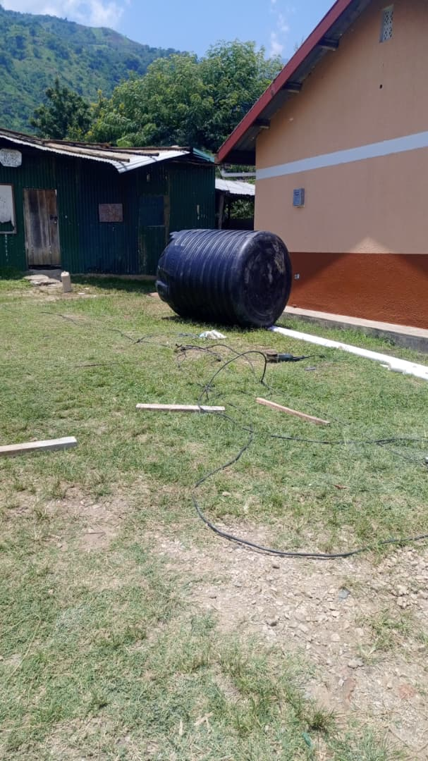
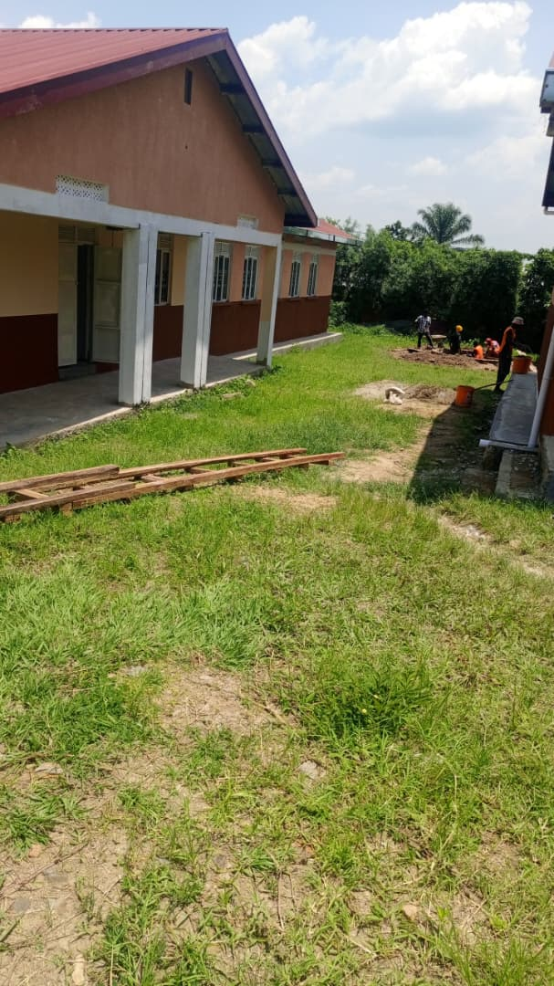
Administration block Un used tank Pit Latrine Unfinished main hall

